# JIRA TO GERRIT INTEGRATION SETUP

1 . Login to jira Machine in Admin level

* 1. Choose administrative

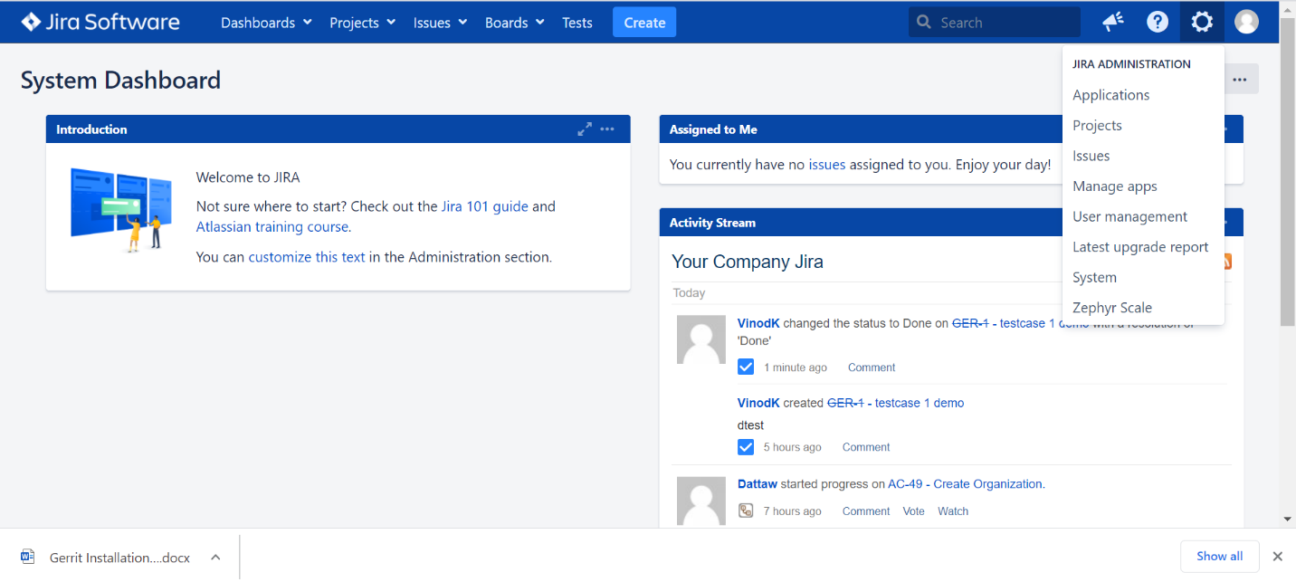

* Click into manage apps

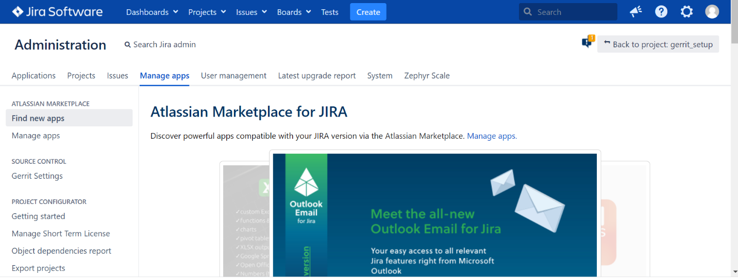

* Search gerrit plugin and install



* After installed plugin choose gerrit setting and upload details
* Use ssh-keygen in Jira machine, take both public & private keys

SSH Host:10.11.93.175

SSH Port:29418

SSH Username:gerritadmin

SSH Private Key:id_rsa ---🡪 choose private key jira machine

Search Queries: %s

Project settings: choose all

Gerrit Projects Whitelist : choose project Name(GERRIT)

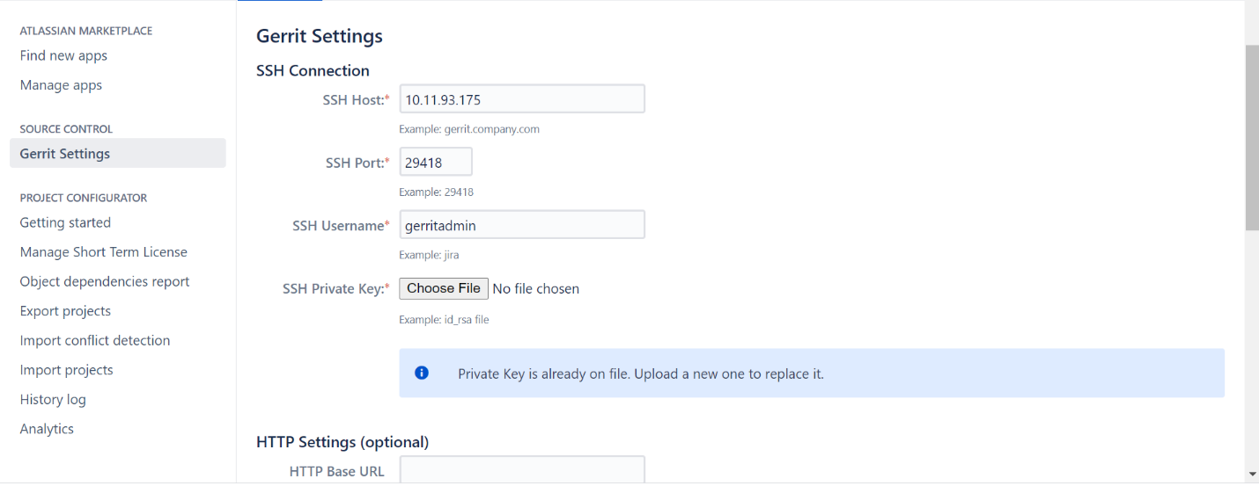

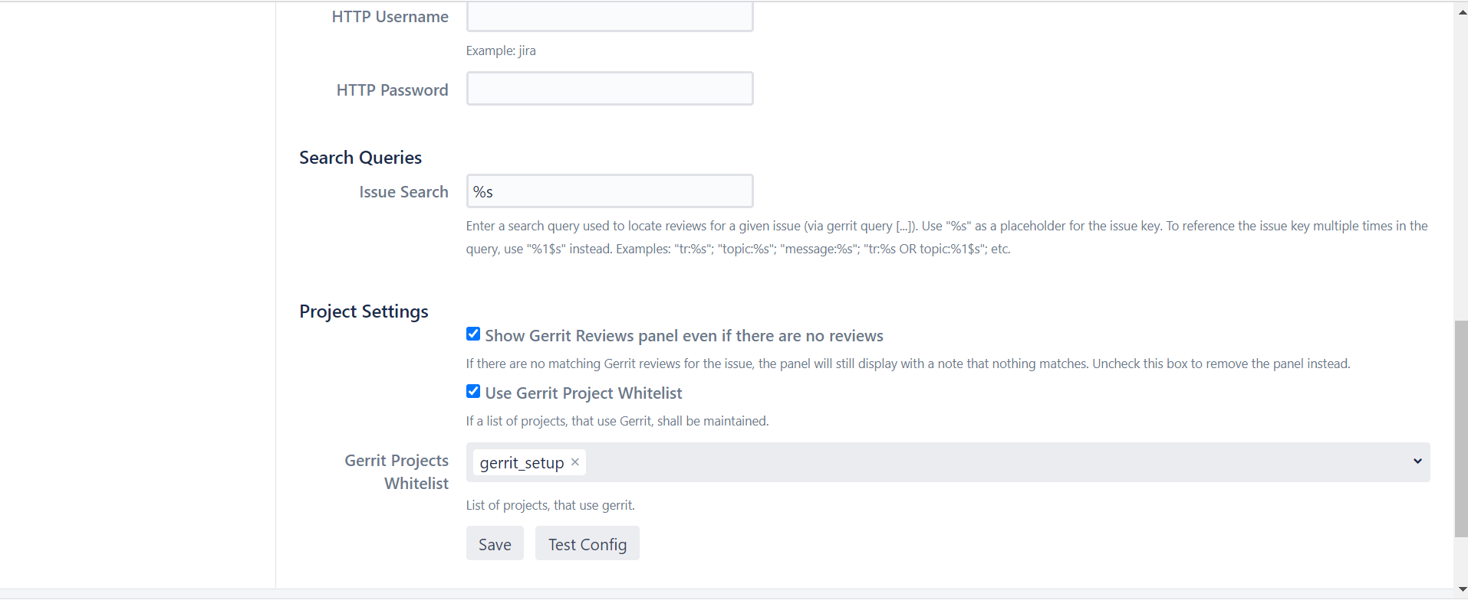

* Publickey copy in Gerrit server
* After TEST CONFIG using test connection

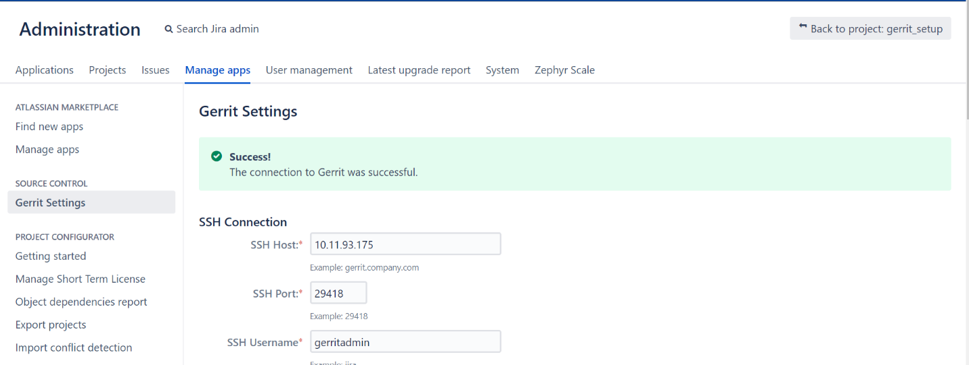

* After Test connection Success , click to save.
  1. Create New project—GERRIT
* Inside project create a issue
* Assign to Task user
  + 1. clone the repo Gerrit to local machine
* git clone "ssh://gerritadmin@10.11.93.175:29418/ACDS"
  + 1. Inside Folder create a Files
* git add .
* Choose task ID – GRE-1



* git commit -s

---🡪 Inside file give message and ISSUE:ID Refer below snap

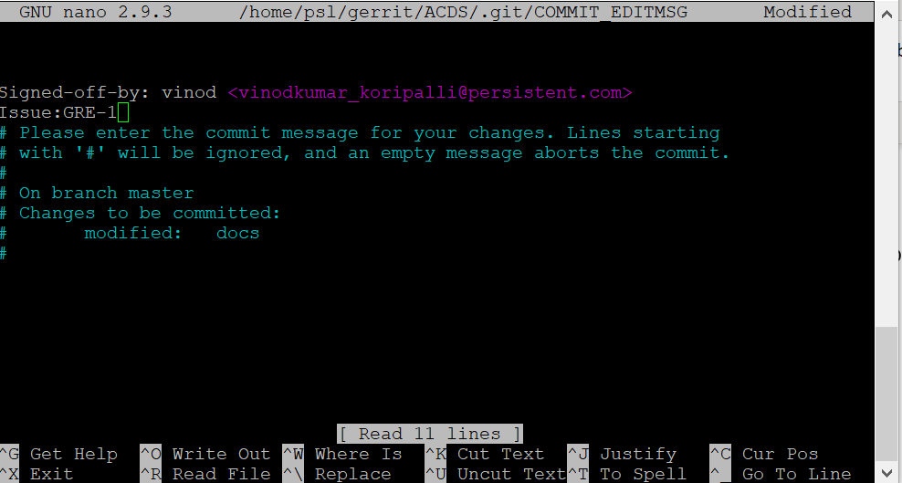

* git push origin HEAD:refs/for/master
  1. After push seeing in Jira project inside issue below snap output
* Gerrit Review output

